**GANPAT UNIVERSITY**

**U.V.PATEL COLLEGE OF ENGINEERING & TECHNOLOGY**

**Department of Computer Science and Engineering**

**B.Tech 1ST Semester   Subject – Essentials of software foundation and programming**

**First Name: Shubham  Enrollment Number:t14012111006  Stream :Mobile applications**

**Assignment -1                                                                             Date:26/8/2014**

1. Write a program to print ASCII values of all backslash characters and white space on screen in following format :

The ASCII value of ‘\t’ is : 9

(Hint : you can verify your ASCII values with the help of a table for ASCII values from text book)

Code:

#include<stdio.h>

#include<conio.h>

void main()

{

clrscr();

char a;

a = '\a';

printf("The ASCII value of \\a is: %d ",a);

a = '\b';

printf("\n The ASCII value of \\b is: %d",a);

a = '\f';

printf("\n The ASCII value of \\f is: %d",a);

a = '\n';

printf("\n The ASCII value of \\n is: %d",a);

a = '\r';

printf("\n The ASCII value of \\r is: %d",a);

a = '\t';

printf("\n The ASCII value of \\t is: %d",a);

a = '\v';

printf("\n The ASCII value of \\v is: %d",a);

a = '\'';

printf("\n The ASCII value of \\' is: %d",a);

a = '\"';

printf("\n The ASCII value of \\\" is: %d",a);

a = '\?';

printf("\n The ASCII value of \\? is: %d",a);

a = '\\';

printf("\n The ASCII value of \\\\ is: %d",a);

a = '10';

printf("\n The ASCII value of 10 is: %d",a);

getch();

}

Outcome:

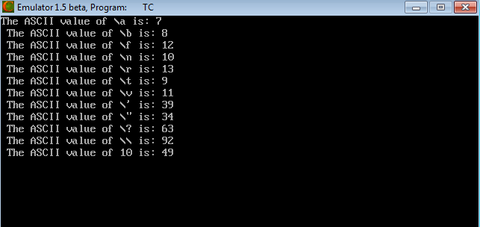

Q2. Explain different data types available in C.

A program usually contains different types of data types (integer, float, character

etc.) and need to store the values being used in the program. C language is rich of data types. A C programmer has to employ proper data type as per his requirements.

There are primarily five data types:

**Integer Data Types:**

Integers are whole numbers with a range of values, range of values are machine dependent.

Generally an integer occupies 2 bytes memory space and its value range limited to -32768 to +32767. To control the range of numbers and storage space, C has three classes of integer storage namely

short int, int and long int. All three data types have signed and unsigned forms. A short int requires half the amount of storage than normal integer. Unlike signed integer, unsigned

integers are always positive and use all the bits for the magnitude of the number. Therefore, the

range of an unsigned integer will be from 0 to 65535. The long integers are used to declare a longer range of values and it occupies 4 bytes of storage space.

**Floating Point Data Types:**

The float data type is used to store fractional numbers (real numbers) with 6 digits of precision.

Floating point numbers are denoted by the keyword float. When the accuracy of the floating point number is insufficient, we can use the double to define the number. The double is same as float but with longer precision and takes double space (8 bytes) than float. To extend the precision further we can use long double which occupies 10 bytes of memory space.

**Character Data Type:**

Character type variable can hold a single character and are declared by using the keyword char. As there are singed and unsigned int (either short or long), in the same way there are signed and unsigned chars; both occupy 1 byte each, but having different ranges. Unsigned characters have values between 0 and 255, signed characters have values from –128 to 127.

**Void Type:**

The void type has no values therefore we cannot declare it as variable as we did in case of integer and float. The void data type is usually used with function to specify its type.

Q3. Explain about C Tokens in brief.

In a C program, the smallest individual units are known as C tokens. C has six types of tokens:

1. Keywords (float,while).
2. Constants (15,16).
3. Identifiers (main,account).
4. Strings (ABC,year).
5. Special symbols ({},[]).
6. Operators (*,+).

Q4. Explain about backslash characters in C.

C supports some backlash character constants that are used in output functions.

For example, the symbol \n stands for newline character.